## engineering College – CoMputer software department

|  |  |  |
| --- | --- | --- |
| **INSTRUCTORS NAME: Dr. Passent Elkafrawy** | | |
| **COURSE NAME: Artificial Intelligence** | **COURSE NUMBER: CS3081** | **SECTION: 1** |

**Student Name: Razan Almahdi**

**Student ID: S20106649**

**Algorithm 1:**

**Name:** Breadth-First Algorithm (BFS)

**Link:** <https://www.gyaanibuddy.com/assignments/assignment-detail/uninformed-search-algorithms-bfsdfs-dls-bf2717/>

**Code:**

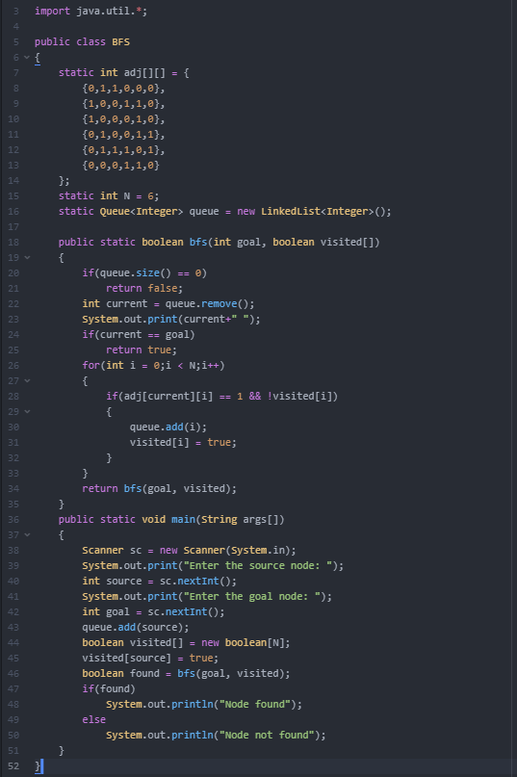

**Output:**

**Test 1: Test 2:**

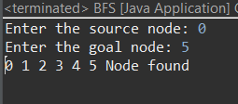 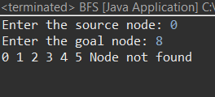

**Algorithm 2:**

**Name:** Depth-First Algorithm (DFS)

**Link:** <https://www.gyaanibuddy.com/assignments/assignment-detail/uninformed-search-algorithms-bfsdfs-dls-bf2717/>

**Code:**

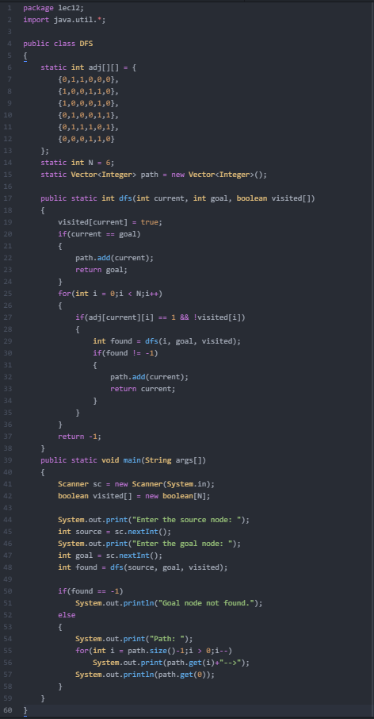

**Output:**

**Test 1: Test 2:**

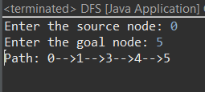 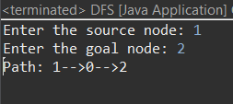

**Algorithm 3:**

**Name:** Iterative-deepening Algorithm (IDS)

**Link:** <https://www.gyaanibuddy.com/assignments/assignment-detail/uninformed-search-algorithms-bfsdfs-dls-bf2717/>

**Code:**

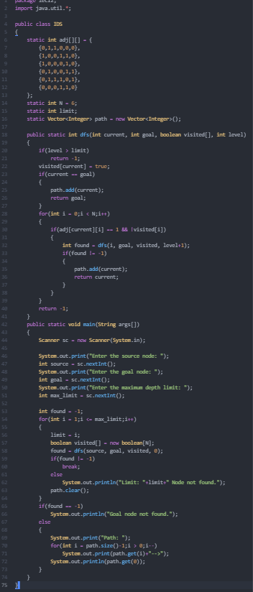

**Output:**

**Test 1: Test 2:**

